SILENT AUCTION ITEM DONATION REQUEST FOR THE 2020 FVMA SCHOLARSHIP FUND

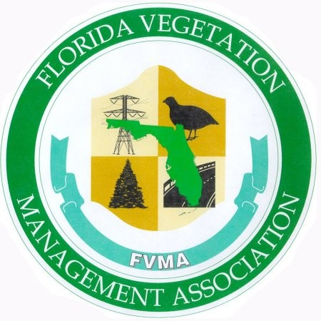
Florida Vegetation Management Association
820 NW 33 Street
Oakland Park, FL 33309-6034

1/17/2020

To Whom It May Concern,

The Florida Vegetation Management Association (FVMA) holds an annual silent auction during its member conference in Daytona Beach to support the FVMA scholarship fund. The scholarship(s) are awarded to qualified individuals who are planning to attend or already enrolled at a college or university in the State of Florida, and are intending to pursue a career within the field of “Vegetation Management”.

ALL proceeds from this fundraiser go directly to the scholarship fund. Any donation you can offer will be a tremendous value to our campaign. Your generosity will help ensure this scholarship is available to the future of our industry, the vegetation managers of tomorrow, who will be responsible for safeguarding our state’s unique ecosystem and natural resources.

Historically, Items such as chain saws, leaf blowers, watches, coolers and handmade crafts have been very popular. Televisions and tablets, weekend getaways, fishing/hunting trips or rounds of golf also make great contributions, but anything at all is appreciated. Our success depends on YOU. We are a 501 (c) (3) and our number can be provided upon request.
Please contact any FVMA Board of Director or Advisor for donation instructions. Their contact information can be found on the FVMA web site: http://www.myfvma.org .
Best Regards,
Georgia Donberg
Scholarship Committee Chair

